The GYEMS.CN RMD-L Series Rotary actuators
Introductory Course

Advantages:
- Built in motor controller and encoder
- Absolute encoder, no calibration
- Reversible - acts as a suspension
- High Torque, Superior to steppers
- Can hold position without burning out. (unlike brushed)
- High torque construction, 4 side threaded holes.
Disadvantages:
- Limited documentation, no Arduino libraries
- RS485 - Not a duplex communication
- Not accurate at low speeds, comparing to steppers
- Built in PID needs improvement - No Derivative Function

We Will Cover:
- Hardware overview
- Connecting to the RMD Motor Assistant - Testing
- Connecting To Arduino ( Teensy 3.6)
- Sending a Command
- Reading a response (Encoders readings)
- Mitch's "Grand Achitecture" for an 10 motor project (Teensy)

Hardware
Various sizes from 40 to 90mm Diameter
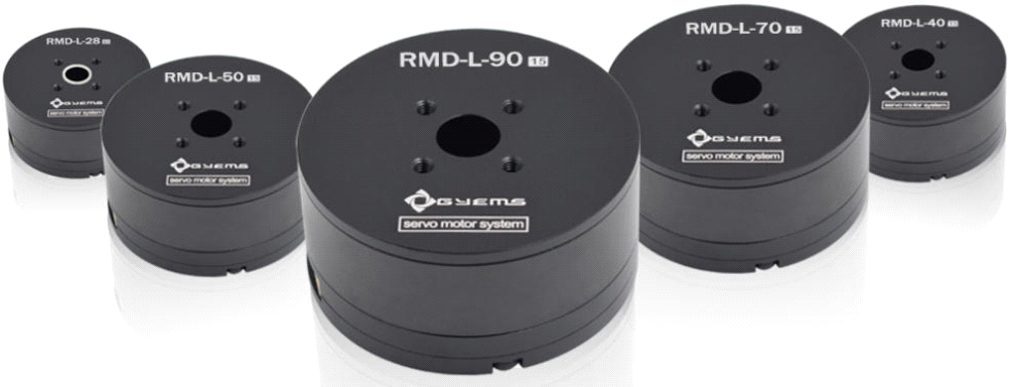
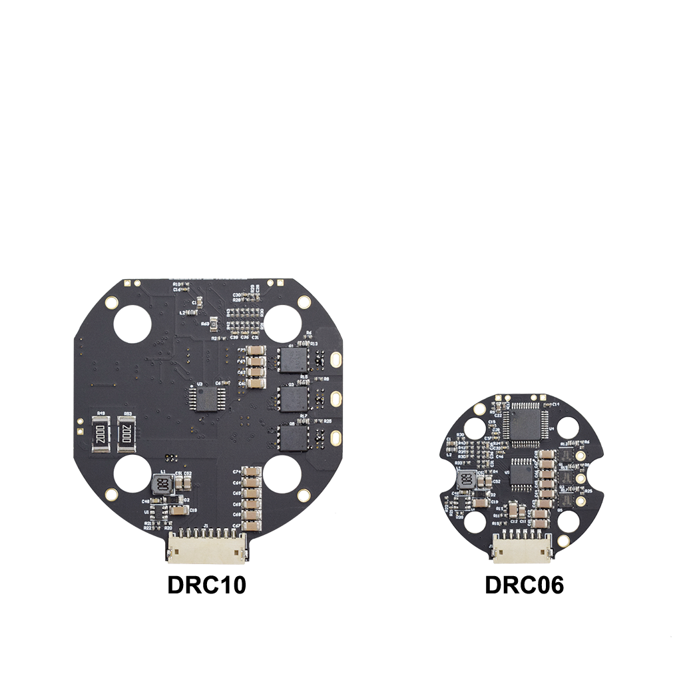
Power and ID Setting:
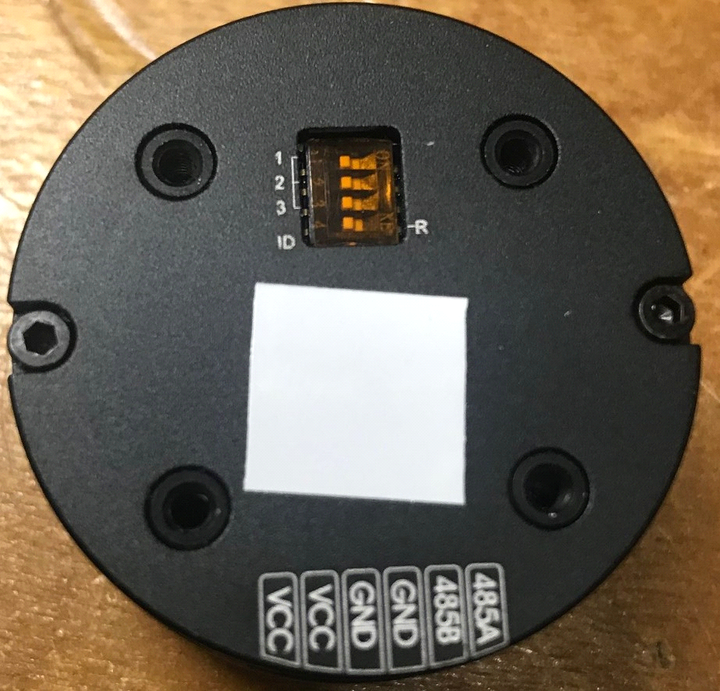
Power - 12 to 16V Max 3 A per motor
ID Truth table 1 to 8 motors per BUS
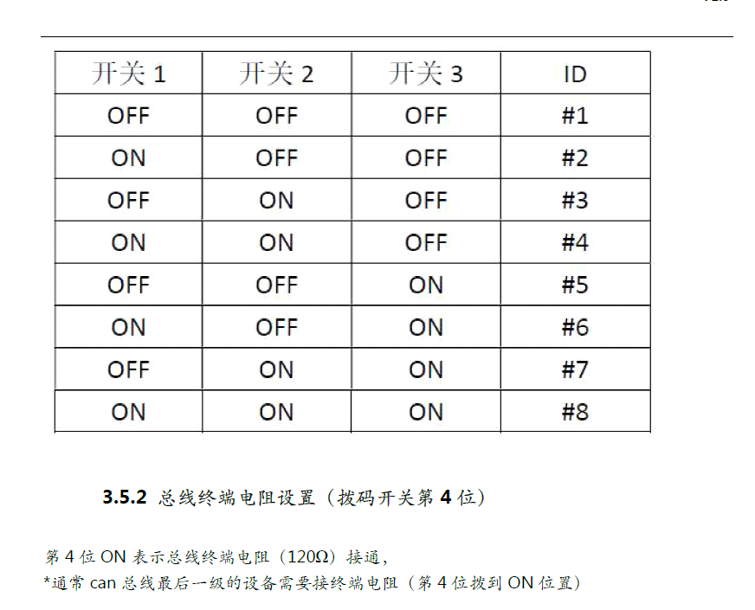
RS 485 to USB ADAPTER Recommend:
DROK TTL to RS485 Adapter Module 485 to TTL Signal Single Chip Serial
USB to UART Recommend:
DSD TECH USB to TTL Serial Converter CP2102 with 4 PIN Dupont Cable Compatible with Windows 7,8,10,Linux,Mac OSX
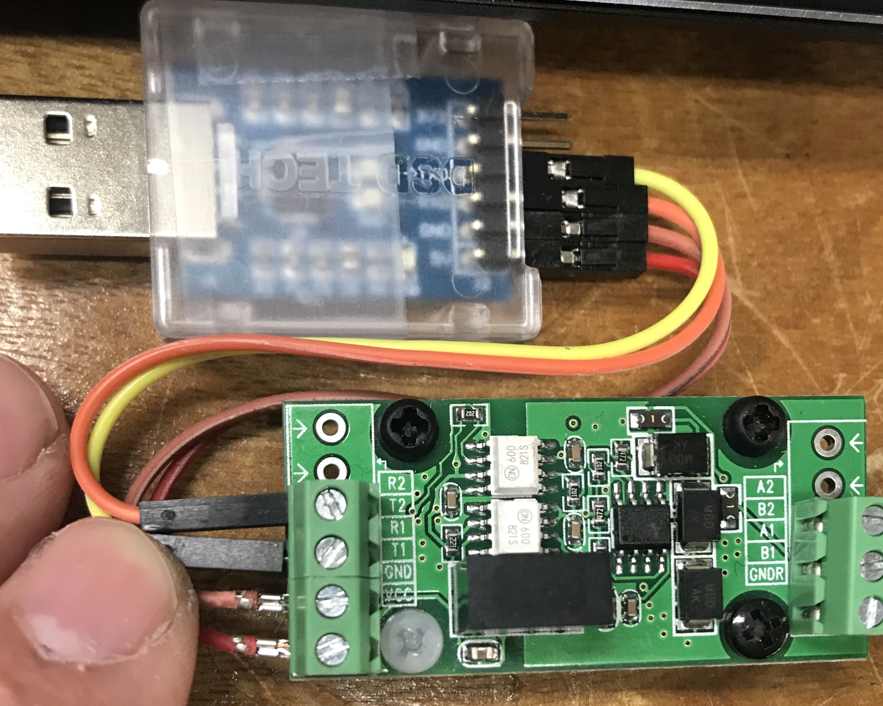
Or you can get a USB to RS485 Convertor, works well
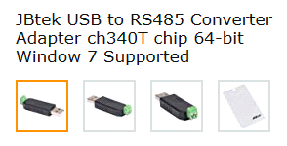

The RMD Motor Assistant
- Connect to USB, Power UP the unit, a green LED should be ON
- In "Device Manager" find your USB to RS adapter COM Port
- Leave the default Baud, Select the proper motor ID.
- The "Disconnect" button means you're connected!

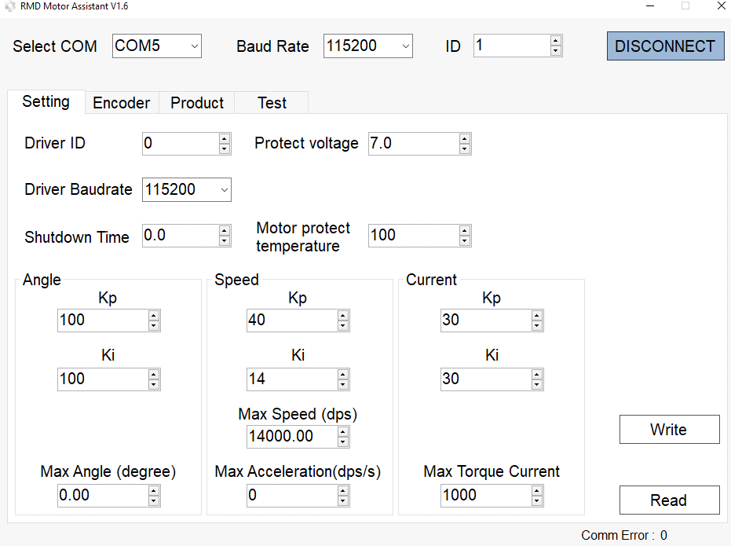

Connecting To Arduino ( Teensy 3.6)
- Hardware setup: RS convertors go UART of the Arduino
RX to RX and TX to TX
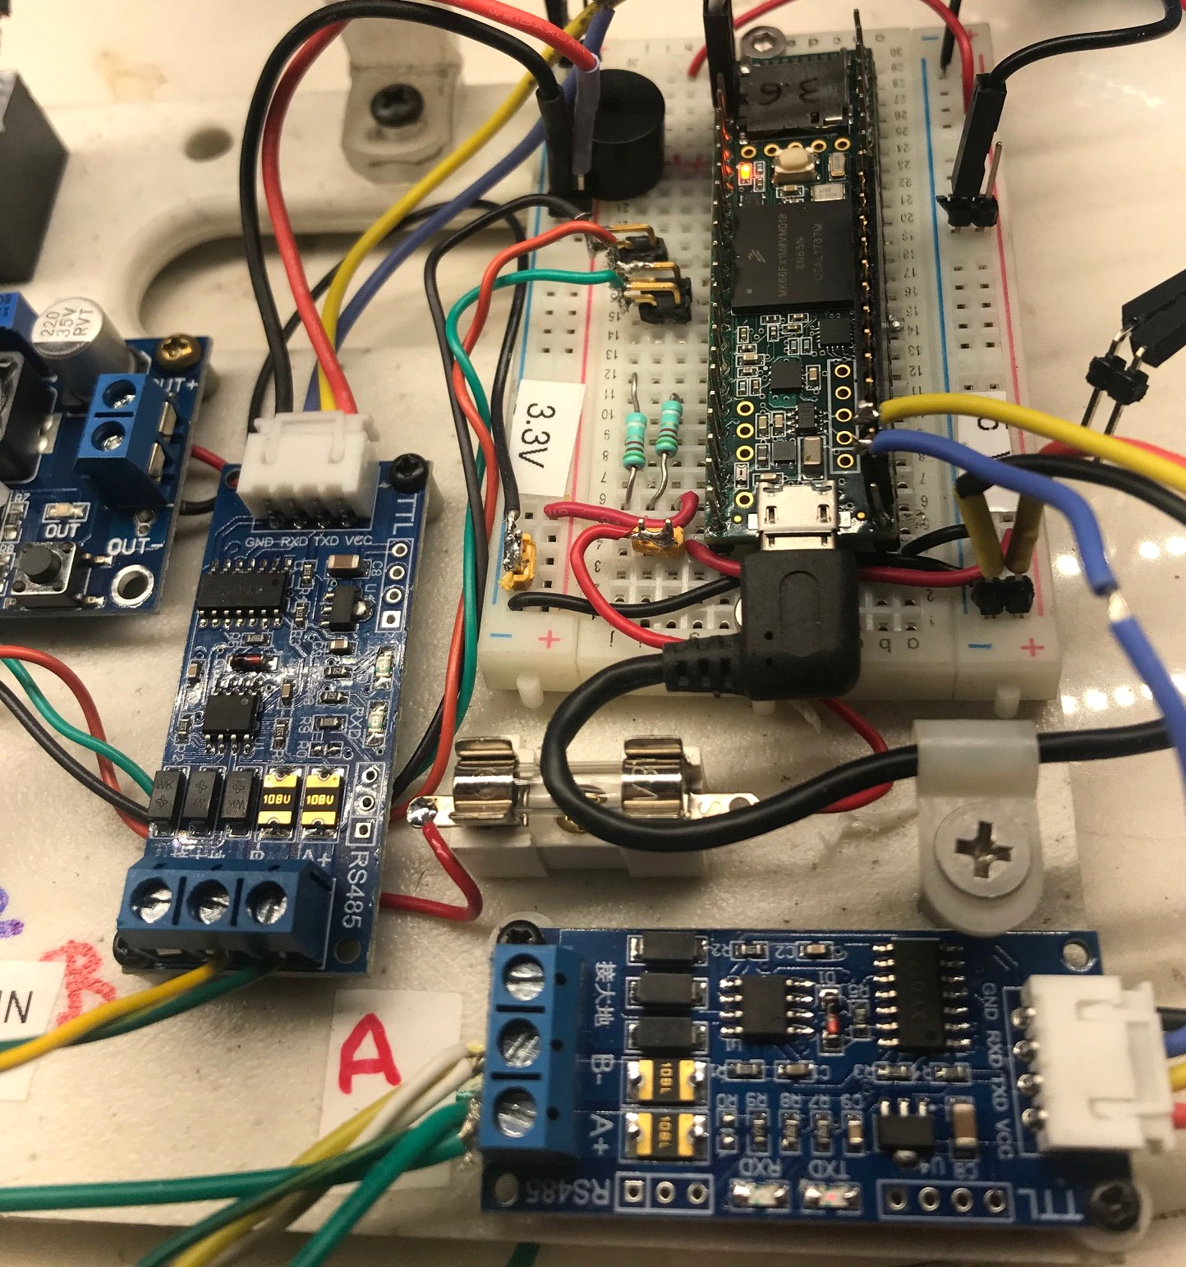

Sending a command
RS485 - is not DUPEX - Remember at all times!
It is based on Ask and Answer. Only RX or TX can travel at one time!
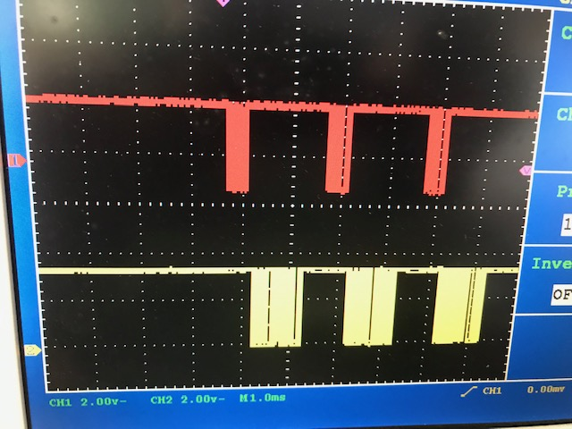

Here we have the Gyems Prototcols:
http://dow.gyems.cn/RMD-servo%20motor%20control%20protocol%20（RS485%29%20V1.6.pdf

Example: Go to Angle at a certain Speed:
User Manual:
- Position closed-loop control command 2 (14byte)
The host computer sends the command to control the position of the motor (multi-turn Angle), the control value angle Control is int64_t, corresponding to the actual position is 0.01degree/LSB, that is 36000 represents 360°, and the motor rotation direction is determined by the difference between the target position and the current position. The control value maxSpeed limits the maximum speed of motor rotation, which is uint32_t type, corresponding to the actual speed of 0.01dps/LSB, namely 36000 represents 360dps.
Data Field | Instructions | Data
DATA[0] | Head byte | 0x3E
DATA[1] | Command byte | 0xA4
DATA[2] | ID byte | 0x01~0x20
DATA[3] | Data length byte | 0x0C
DATA[4] | Frame header check byte | DATA[0]~DATA[3]byte checksum
DATA[5] | Position control low byte 1 | DATA[5] = *(uint8_t *)(&angleControl)
DATA[6] | Position control byte 2 | DATA[6] = *((uint8_t *)(&angleControl)+1)
DATA[7] | Position control byte 3 | DATA[7] = *((uint8_t *)(&angleControl)+2)
DATA[8] | Position control byte 4 | DATA[8] = *((uint8_t *)(&angleControl)+3)
DATA[9] | Position control byte 5 | DATA[9] = *((uint8_t *)(&angleControl)+4)
DATA[10] | Position control byte 6 | DATA[10] = *((uint8_t *)(&angleControl)+5)
DATA[11] | Position control byte 7 | DATA[11] = *((uint8_t *)(&angleControl)+6)
DATA[12] | Position control high byte 1 | DATA[12] = *((uint8_t *)(&angleControl)+7)
DATA[13] | Speed limit low byte 1 | DATA[13] = *(uint8_t *)(&maxSpeed)
DATA[14] | Speed limit byte 2 | DATA[14] = *((uint8_t *)(&maxSpeed)+1)
DATA[15] | Speed limit byte 3 | DATA[15] = *((uint8_t *)(&maxSpeed)+2)
DATA[16] | Speed limit high byte 4 | DATA[16] = *((uint8_t *)(&maxSpeed)+3)
DATA[17] | Data check byte | DATA[5]~DATA[16]byte checksum

Arduino Code:
if (inChar == 'g')
{
Angle_Speed (0, 200.03, 1); // this is 0º at 200º/sec , motor 1
delay (2);
}
void Angle_Speed (float m_angle, float m_speed, unsigned char motor_id)

{
long motor_angle = m_angle * 100;
int motor_speed = m_speed * 100;
byte cmd_send_buf[18];
cmd_send_buf[0] = 0x3E; //header
cmd_send_buf[1] = 0xA4; // cmd_id-- position mode 2
cmd_send_buf[3] = 0x0C; // data length
cmd_send_buf[4] = cmd_send_buf[0] + cmd_send_buf[1] + cmd_send_buf[2] +cmd_send_buf[3] ;
cmd_send_buf[5] = motor_angle; // angle data low byte - unit 0.01 degrees
cmd_send_buf[6] = motor_angle >> 8;
cmd_send_buf[7] = motor_angle >> 16;
cmd_send_buf[8] = motor_angle >> 24;
cmd_send_buf[9] = motor_angle >> 32;
cmd_send_buf[10] = motor_angle >> 40;
cmd_send_buf[11] = motor_angle >> 48;
cmd_send_buf[12] = motor_angle >> 56;

cmd_send_buf[13] = motor_speed; // speed data low byte 0.01 deg per sec
cmd_send_buf[14] = motor_speed >> 8;
cmd_send_buf[15] = motor_speed >> 16;
cmd_send_buf[16] = motor_speed >> 24;
cmd_send_buf[17] = cmd_send_buf[5] + cmd_send_buf[6] + cmd_send_buf[7] + cmd_send_buf[8] + cmd_send_buf[9] + cmd_send_buf[10]+ cmd_send_buf[11] + cmd_send_buf[12] + cmd_send_buf[13] + cmd_send_buf[14] + cmd_send_buf[15] + cmd_send_buf[16]; // check sum .
Serial1.write (cmd_send_buf, 18);
delay (2);
}

Reading a response (Encoders readings)
Function written by the famous Paul Stoffregen
It is essential to read encoders!
Arduino Code: Read Request based on motor ID:
void Read_Enc ( unsigned char motor_id)
{ //16383 steps per turn
byte cmd_send_buf[5];
cmd_send_buf[0] = 0x3E; //header
cmd_send_buf[1] = 0x90; // cmd_id-- Read enc
cmd_send_buf[2] = motor_id;
cmd_send_buf[3] = 0x00; // data lenght
cmd_send_buf[4] = cmd_send_buf[0] + cmd_send_buf[1] + cmd_send_buf[2] + cmd_send_buf[3]; // check sum
Serial1.write (cmd_send_buf, 5);
delay (2);// wait for response
}
Response from the motor processing:
if (Serial1.available()) {
uint8_t b = Serial1.read(); // always read the first incoming byte
if (b == 0x3E) {
num_received = 0; // if begin of message, forget everything previously received
//Serial.println ("new message:");
}
else {
mybuffer[num_received+1] = b; // otherwise, put the byte into the buffer
num_received = num_received + 1;
if (num_received == 11 && mybuffer[1] == 0x90 )
{ Enc_Calc(); // function to extract encoder readings from
}
} // end of "if getting bytes in the array

// check if the buffer is full (shouldn't happen, right?)
if (num_received >= 20) {
num_received = 0; // discard everything
PrintOnce = 0;
Serial.print(" Overflow ");
} // end of else iteration
Converting the incoming Encoder reading in an angle for each motor number:
void Enc_Calc()
{ int Enc_Read = mybuffer[5] + (mybuffer[6] << 8);
Mot_Ang_Read = (360 * Enc_Read) / 16383.00;
Serial.print(mybuffer[2], DEC); // the motor id, there are up to 8 on a bus.
Serial.print(": ");
Serial.print(Mot_Ang_Read, 2);
Serial.println("°");
}

Mitch's "Grand Achitecture" for an 10 motor project (Teensy)
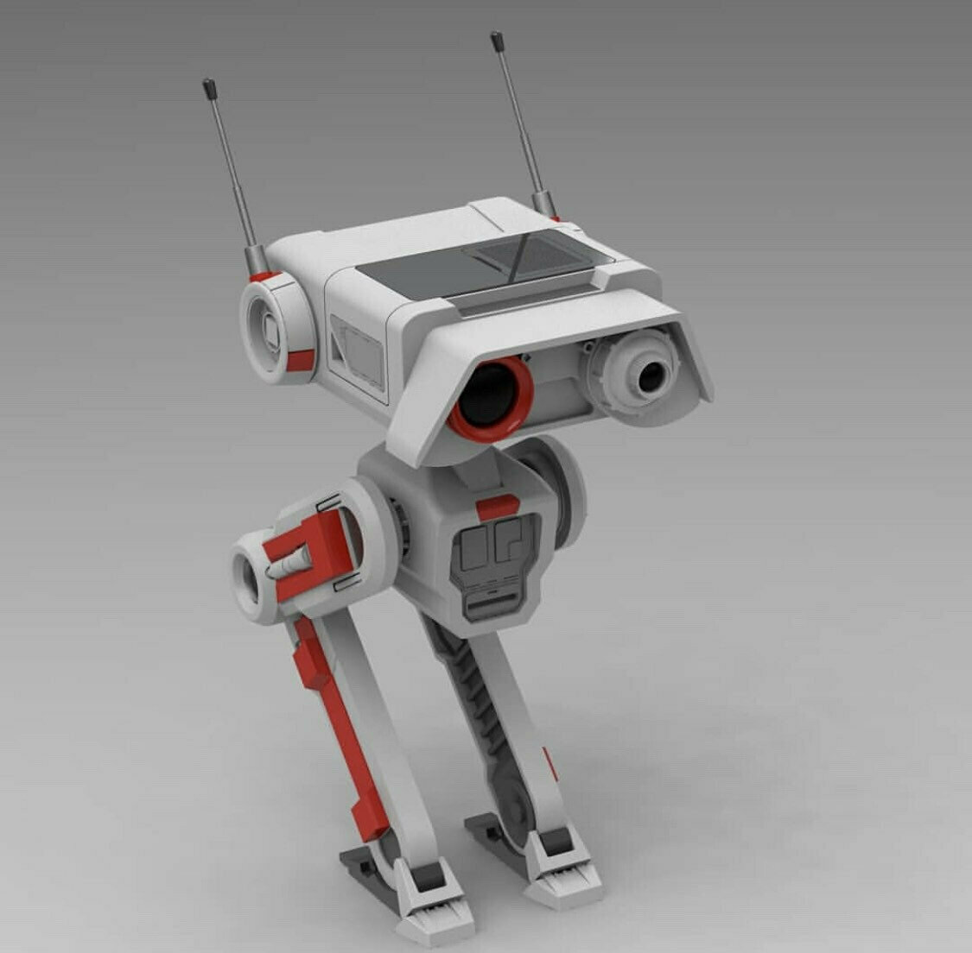
- There will be 2 RS to UART Ports, each controlling 8 motors .
- Knowing all legs angles at all times, the center of gravity can be positioned above the foot signature of the robot.
- An IMU will keep track of the attitude.
Your questions at: Haralambie@yahoo.com

